**CSE2006-MICROPROCESSORS AND INTERFACING**

**NAME:** O G RAGAVI

**REG NO:** 20BCE1988

**EX NO:** 10

**TITLE: HARDWARE IMPLEMENTATION ( FACTORIAL ,ASCENDING AND DESCENDING ORDER)**

1.TO FIND THE FACTORIAL OF A NUMBER:

**CODE:**

MOV CX,0005H

MOV AX,0001H

MOV BX,AX

LOOP1: INC BX

MUL BX

CMP BX,CX

JNZ LOOP1

MOV [2000],AX

HLT

**INPUT:** 5

**OUTPUT:** 120; 78 IN HEXADECIMAL.

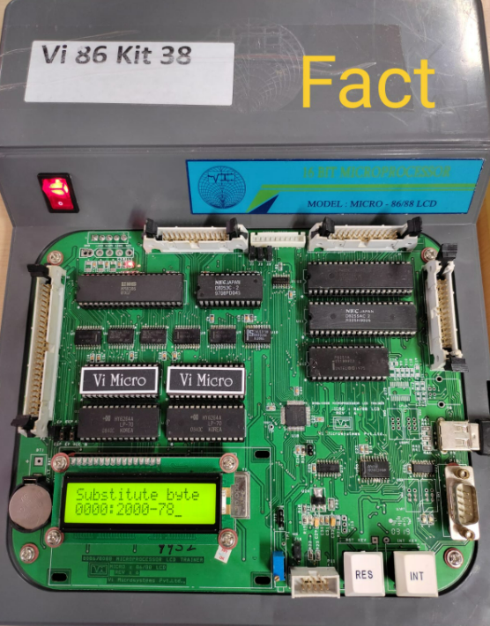

2.TO ARRANGE THE GIVEN ELEMENTS OF AN ARRAY IN ASCENDING ORDER:

**CODE:**

MOV [2001],10H

MOV [2002],25H

MOV [2003],22H

MOV [2004],7H

MOV [2005],13H

MOV CH,05H

UP2:MOV CL,05H

MOV SI,2001

UP1:MOV AL,[SI]

MOV BL,[SI+1]

CMP AL,BL

JC DOWN

MOV DL,[SI+1]

XCHG [SI],DL

MOV [SI+1],DL

DOWN:INC SI

DEC CL

JNZ UP1

DEC CH

JNZ UP2

HLT

**INPUT:**  10,25,22,7,13

**OUTPUT:**  7,10,13,22,25

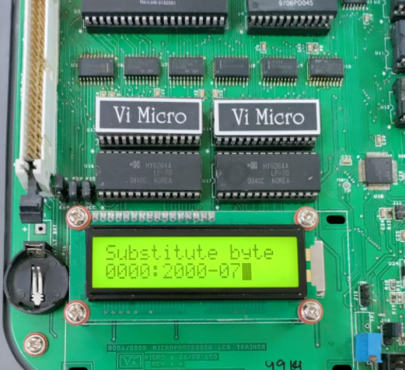

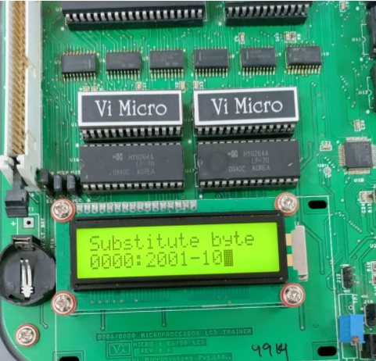

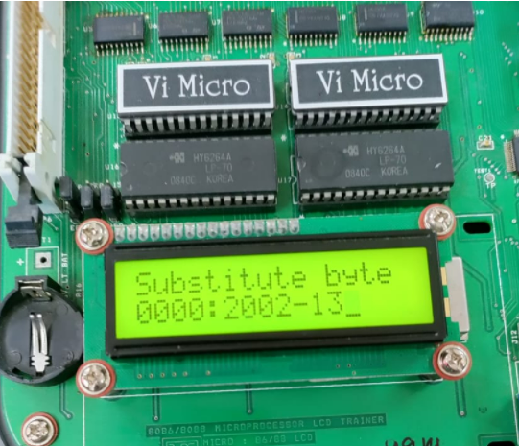

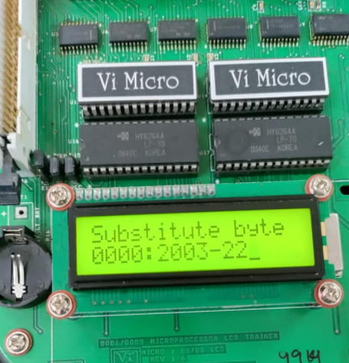

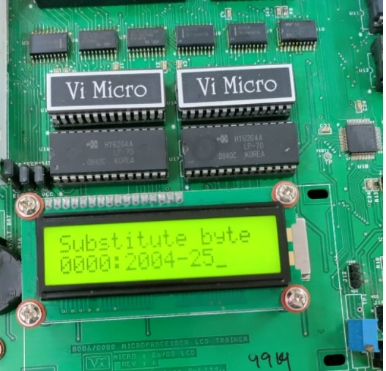

3. TO ARRANGE THE GIVEN ELEMENTS OF AN ARRAY IN DESCENDING ORDER:

**CODE:**

MOV [2001],10H

MOV [2002],25H

MOV [2003],22H

MOV [2004],7H

MOV [2005],13H

MOV CH,05H

UP2:MOV CL,05H

MOV SI,2001

UP1:MOV AL,[SI]

MOV BL,[SI+1]

CMP BL,AL

JC DOWN

MOV DL,[SI+1]

XCHG [SI],DL

MOV [SI+1],DL

DOWN:INC SI

DEC CL

JNZ UP1

DEC CH

JNZ UP2

HLT

**INPUT:** 10,25,22,7,13

**OUTPUT:**  25,22,13,10,7

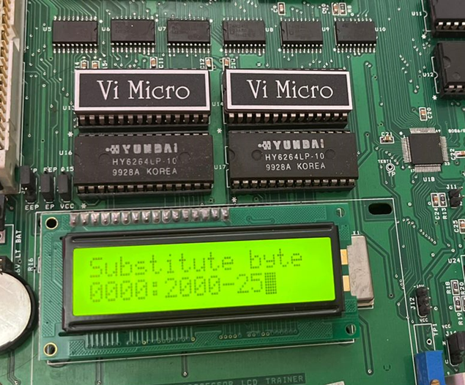

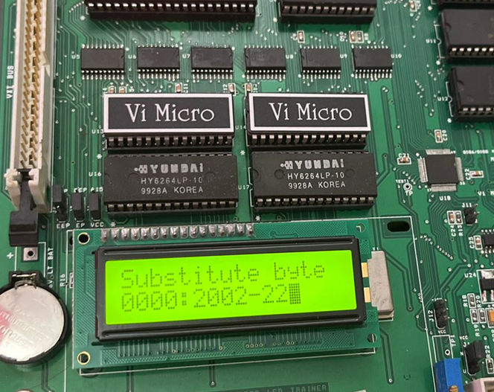

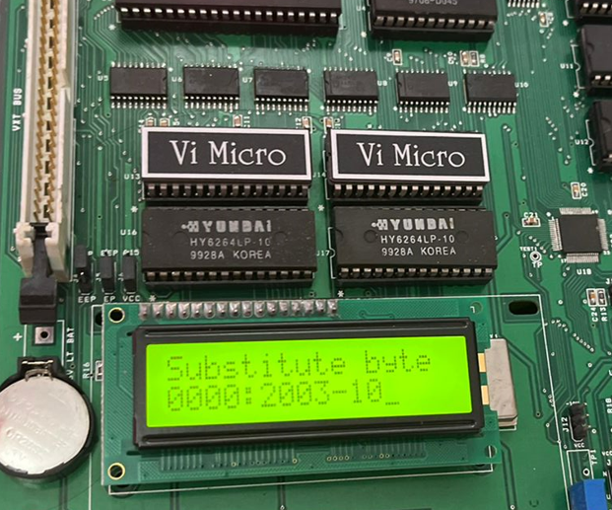

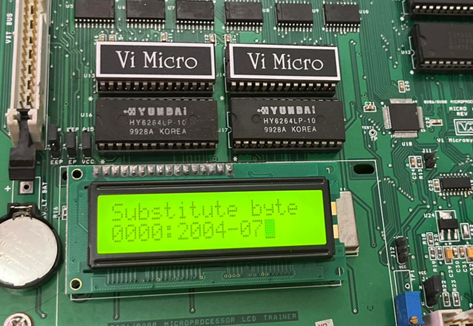

**RESULT:**

Hence, the alp for factorial, ascending order and descending order is implemented in hardware.